ai-phase3

October 18, 2023



[1]: *#IMPORTING THE LIBRARIES*

**import pandas as pd**

**import numpy as np**

**import seaborn as sns**

**import matplotlib.pyplot as plt**

**from sklearn.model_selection import** train_test_split **from sklearn.preprocessing import** StandardScaler

**from sklearn.metrics import** r2_score, mean_absolute_error,mean_squared_error **from sklearn.linear_model import** LinearRegression **from sklearn.linear_model import** Lasso

**from sklearn.ensemble import** RandomForestRegressor **from sklearn.svm import** SVR **import xgboost as xg**

*#IMPORTING & LOADING THE DATASET*

print("_______________")

print("THE DATASET IS:")

print("_______________")

print()

dataset = pd.read_csv("C:/Users/amald/OneDrive/Desktop/jupyter/USA HOUSING.csv")

print(dataset)

print()

print()

*#PREPROCESSING THE DATASET*

print("_____________________________")

print("THE INFORMATION ABOUT DATASET:")

print("_____________________________")

print()

print(dataset.info())

print()

print("___________________")

print("DESCRIBING DATASET:")

print("___________________")

print()

print(dataset.describe())

1



print()

print("________________")

print("THE COLUMNS ARE:")

print("________________")

print()

print(dataset.columns)

print()

print("_________")

print("HISTPLOT:")

print("_________")

print()

m=sns.histplot(dataset, x='Price', bins=50, color='y')

plt.show()

print()

print("________")

print("JOINTPLOT:")

print("________")

sns.jointplot(dataset, x='Avg. Area House Age', y='Price', kind='hex')

sns.jointplot(dataset, x='Avg. Area Income', y='Price')

plt.show()

print()

print("_________")

print("HISTOGRAM")

print("_________")

dataset.hist(figsize=(10,8))

plt.show()

print("_________________")

print("CORRELATING DATA:")

print("_________________")

print(dataset.corr(numeric_only=**True**))

print()

print("________")

print("HEATMAP:")

print("________")

sns.heatmap(dataset.corr(numeric_only = **True**), annot=**True**)

plt.show()

print()

*#DIVIDING DATASET INTO FEATURES AND TARGET*

x = dataset[['Avg. Area Income', 'Avg. Area House Age', 'Avg. Area Number of␣ ↪Rooms',

'Avg. Area Number of Bedrooms', 'Area Population']] y = dataset['Price']

print()

print("THE VALUE OF X IS:")

print()

print(x)

2

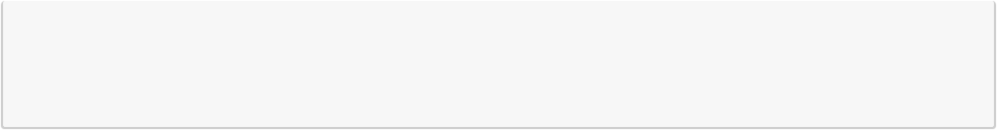

print()

print("THE VALUE OF Y IS:")

print()

print(y)

_______________

THE DATASET IS:

_______________

|  |  |  |  |
| --- | --- | --- | --- |
|  | Avg. Area Income | Avg. Area House Age | Avg. Area Number of Rooms \ |
| 0 | 79545.45857 | 5.682861 | 7.009188 |
| 1 | 79248.64245 | 6.002900 | 6.730821 |
| 2 | 61287.06718 | 5.865890 | 8.512727 |
| 3 | 63345.24005 | 7.188236 | 5.586729 |
| 4 | 59982.19723 | 5.040555 | 7.839388 |
| … | … | … | … |
| 4995 | 60567.94414 | 7.830362 | 6.137356 |
| 4996 | 78491.27543 | 6.999135 | 6.576763 |
| 4997 | 63390.68689 | 7.250591 | 4.805081 |
| 4998 | 68001.33124 | 5.534388 | 7.130144 |
| 4999 | 65510.58180 | 5.992305 | 6.792336 |

|  |  |  |  |
| --- | --- | --- | --- |
|  | Avg. Area Number of Bedrooms | Area Population | Price \ |
| 0 | 4.09 | 23086.80050 | 1.059034e+06 |
| 1 | 3.09 | 40173.07217 | 1.505891e+06 |
| 2 | 5.13 | 36882.15940 | 1.058988e+06 |
| 3 | 3.26 | 34310.24283 | 1.260617e+06 |
| 4 | 4.23 | 26354.10947 | 6.309435e+05 |
| … | … | … | … |
| 4995 | 3.46 | 22837.36103 | 1.060194e+06 |
| 4996 | 4.02 | 25616.11549 | 1.482618e+06 |
| 4997 | 2.13 | 33266.14549 | 1.030730e+06 |
| 4998 | 5.44 | 42625.62016 | 1.198657e+06 |
| 4999 | 4.07 | 46501.28380 | 1.298950e+06 |

Address

* 208 Michael Ferry Apt. 674\nLaurabury, NE 3701…

1188 Johnson Views Suite 079\nLake Kathleen, CA…

29127 Elizabeth Stravenue\nDanieltown, WI 06482…

|  |  |  |
| --- | --- | --- |
| 3 | USS Barnett\nFPO | AP 44820 |
| 4 | USNS Raymond\nFPO | AE 09386 |
| … |  | … |
| 4995 | USNS Williams\nFPO AP 30153-7653 | |
| 4996 | PSC 9258, Box 8489\nAPO AA 42991-3352 | |
| 4997 | 4215 Tracy Garden Suite 076\nJoshualand, | VA 01… |
| 4998 | USS Wallace\nFPO | AE 73316 |
| 4999 | 37778 George Ridges Apt. 509\nEast Holly, NV 2… | |

3

|  |  |  |  |  |
| --- | --- | --- | --- | --- |
| [5000 rows x 7 columns] | |  |  |  |
| _____________________________ | |  |  |  |
| THE INFORMATION ABOUT DATASET: | |  |  |  |
| _____________________________ | |  |  |  |
| <class 'pandas.core.frame.DataFrame'> | | |  |  |
| RangeIndex: 5000 entries, 0 to 4999 | | |  |  |
| Data | columns (total 7 columns): |  |  |  |
| # | Column | Non-Null Count | | Dtype |
| --- | ------ | -------------- | | ----- |
| 0 | Avg. Area Income | 5000 | non-null | float64 |
| 1 | Avg. Area House Age | 5000 | non-null | float64 |
| 2 | Avg. Area Number of Rooms | 5000 | non-null | float64 |
| 3 | Avg. Area Number of Bedrooms | 5000 | non-null | float64 |
| 4 | Area Population | 5000 | non-null | float64 |
| 5 | Price | 5000 | non-null | float64 |
| 6 | Address | 5000 | non-null | object |
| dtypes: float64(6), object(1) | |  |  |  |
| memory usage: 273.6+ KB | |  |  |  |
| None |  |  |  |  |
| ___________________ | |  |  |  |
| DESCRIBING DATASET: | |  |  |  |
| ___________________ | |  |  |  |
|  | Avg. Area Income Avg. Area House Age Avg. Area Number of Rooms \ | | | |
| count | 5000.000000 | 5000.000000 | | 5000.000000 |
| mean | 68583.108984 | 5.977222 | | 6.987792 |
| std | 10657.991214 | 0.991456 | | 1.005833 |
| min | 17796.631190 | 2.644304 | | 3.236194 |
| 25% | 61480.562390 | 5.322283 | | 6.299250 |
| 50% | 68804.286405 | 5.970429 | | 7.002902 |
| 75% | 75783.338665 | 6.650808 | | 7.665871 |
| max | 107701.748400 | 9.519088 | | 10.759588 |

|  |  |  |  |
| --- | --- | --- | --- |
|  | Avg. Area Number of Bedrooms | Area Population | Price |
| count | 5000.000000 | 5000.000000 | 5.000000e+03 |
| mean | 3.981330 | 36163.516039 | 1.232073e+06 |
| std | 1.234137 | 9925.650114 | 3.531176e+05 |
| min | 2.000000 | 172.610686 | 1.593866e+04 |
| 25% | 3.140000 | 29403.928700 | 9.975771e+05 |
| 50% | 4.050000 | 36199.406690 | 1.232669e+06 |
| 75% | 4.490000 | 42861.290770 | 1.471210e+06 |
| max | 6.500000 | 69621.713380 | 2.469066e+06 |

4

________________

THE COLUMNS ARE:

________________

Index(['Avg. Area Income', 'Avg. Area House Age', 'Avg. Area Number of Rooms', 'Avg. Area Number of Bedrooms', 'Area Population', 'Price', 'Address'],

dtype='object')

_________

HISTPLOT:

_________

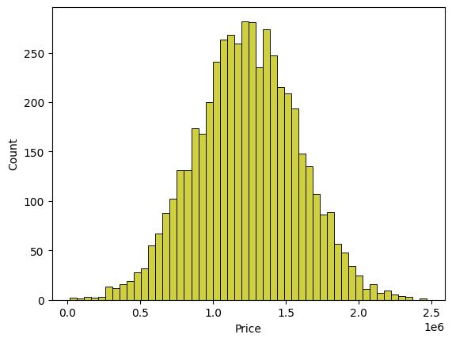

________

JOINTPLOT:

________

5

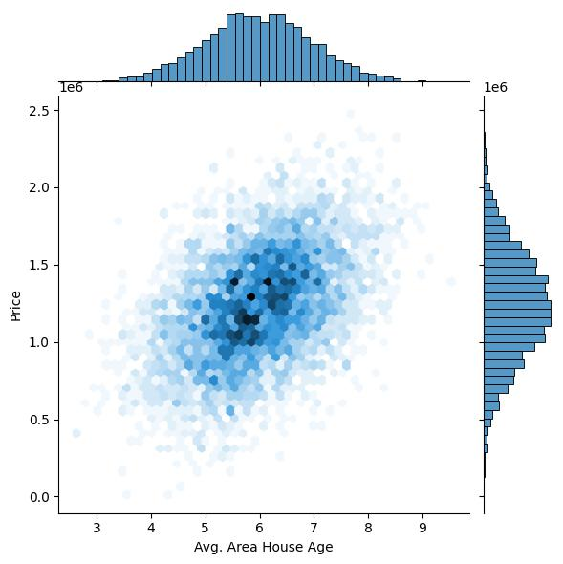

6

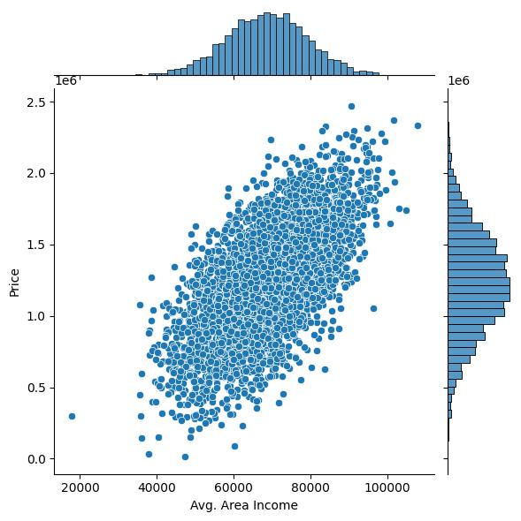

_________

HISTOGRAM

_________

7

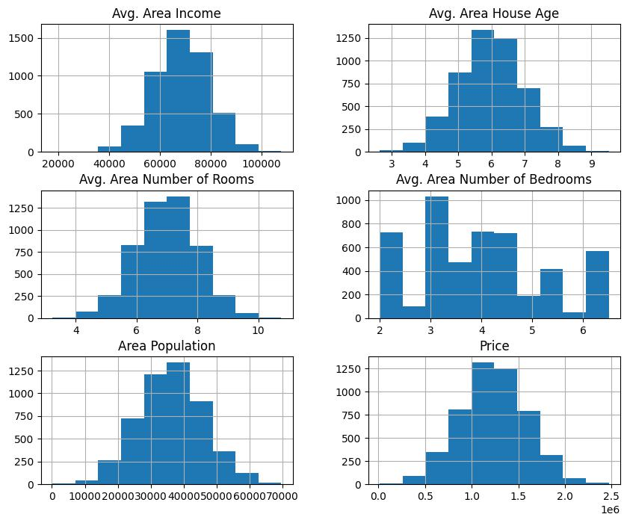

|  |  |  |  |
| --- | --- | --- | --- |
| _________________ |  |  |  |
| CORRELATING DATA: |  |  |  |
| _________________ | Avg. Area Income | Avg. Area House Age \ |  |
|  |  |
| Avg. Area Income | 1.000000 | -0.002007 |  |
| Avg. Area House Age | -0.002007 | 1.000000 |  |
| Avg. Area Number of Rooms | -0.011032 | -0.009428 |  |
| Avg. Area Number of Bedrooms | 0.019788 | 0.006149 |  |
| Area Population | -0.016234 | -0.018743 |  |
| Price | 0.639734 | 0.452543 |  |

|  |  |  |
| --- | --- | --- |
|  |  | Avg. Area Number of Rooms \ |
| Avg. Area Income |  | -0.011032 |
| Avg. Area House Age |  | -0.009428 |
| Avg. Area Number of | Rooms | 1.000000 |
| Avg. Area Number of | Bedrooms | 0.462695 |
| Area Population |  | 0.002040 |
| Price |  | 0.335664 |

8

|  |  |  |  |
| --- | --- | --- | --- |
|  |  | Avg. Area Number of Bedrooms | Area Population \ |
| Avg. Area Income |  | 0.019788 | -0.016234 |
| Avg. Area House Age |  | 0.006149 | -0.018743 |
| Avg. Area Number of | Rooms | 0.462695 | 0.002040 |
| Avg. Area Number of | Bedrooms | 1.000000 | -0.022168 |
| Area Population |  | -0.022168 | 1.000000 |
| Price |  | 0.171071 | 0.408556 |
|  |  | Price |  |
| Avg. Area Income |  | 0.639734 |  |
| Avg. Area House Age |  | 0.452543 |  |
| Avg. Area Number of | Rooms | 0.335664 |  |
| Avg. Area Number of | Bedrooms | 0.171071 |  |
| Area Population |  | 0.408556 |  |
| Price |  | 1.000000 |  |

________

HEATMAP:

________

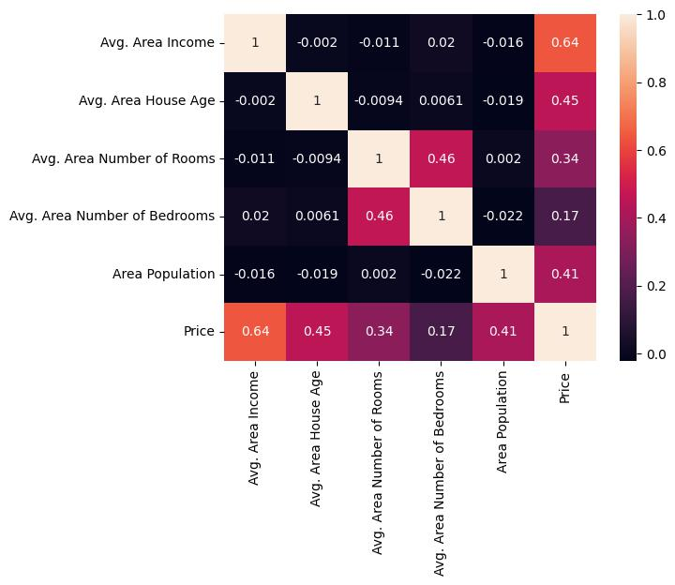

9

|  |  |  |  |
| --- | --- | --- | --- |
| THE VALUE OF X IS: | |  |  |
|  | Avg. Area Income | Avg. Area House Age | Avg. Area Number of Rooms \ |
| 0 | 79545.45857 | 5.682861 | 7.009188 |
| 1 | 79248.64245 | 6.002900 | 6.730821 |
| 2 | 61287.06718 | 5.865890 | 8.512727 |
| 3 | 63345.24005 | 7.188236 | 5.586729 |
| 4 | 59982.19723 | 5.040555 | 7.839388 |
| … | … | … | … |
| 4995 | 60567.94414 | 7.830362 | 6.137356 |
| 4996 | 78491.27543 | 6.999135 | 6.576763 |
| 4997 | 63390.68689 | 7.250591 | 4.805081 |
| 4998 | 68001.33124 | 5.534388 | 7.130144 |
| 4999 | 65510.58180 | 5.992305 | 6.792336 |

|  |  |  |
| --- | --- | --- |
|  | Avg. Area Number of Bedrooms | Area Population |
| 0 | 4.09 | 23086.80050 |
| 1 | 3.09 | 40173.07217 |
| 2 | 5.13 | 36882.15940 |
| 3 | 3.26 | 34310.24283 |
| 4 | 4.23 | 26354.10947 |
| … | … | … |
| 4995 | 3.46 | 22837.36103 |
| 4996 | 4.02 | 25616.11549 |
| 4997 | 2.13 | 33266.14549 |
| 4998 | 5.44 | 42625.62016 |
| 4999 | 4.07 | 46501.28380 |

[5000 rows x 5 columns]

THE VALUE OF Y IS:

* 1.059034e+06
* 1.505891e+06
* 1.058988e+06
* 1.260617e+06
* 6.309435e+05

…

4995 1.060194e+06

4996 1.482618e+06

4997 1.030730e+06

4998 1.198657e+06

4999 1.298950e+06

10

Name: Price, Length: 5000, dtype: float64

11